“This is a Special Payment to you under a collectively negotiated agreement

between the American Federation of Musicians and recording company

signatories.”

**SOUND RECORDING**

**SPECIAL PAYMENTS FUND**

**570 Lexington Avenue, Suite 360**

**New York, NY 10022**

**SOUND RECORDING**

**SPECIAL PAYMENTS FUND**

**570 Lexington Avenue, Suite 360**

**New York, NY 10022**

■

615-777015

**JPMorgan Chase Bank, N.A.**

**Syracuse, NY 13206**

**CHECK AMOUNT**

50-937

213

**AUTHORIZED SIGNATURE NOT VALID OVER 90 DAYS**

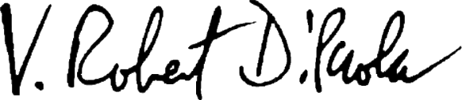

“This is a Special Payment to you under a collectively negotiated agreement

between the American Federation of Musicians and recording company

signatories.”